**Documentation – Food Inspection Facility**Team 5

Sashank Machiraju

Neha Reddy

Manimanya Reddy

Prithika Purushothaman

In this document we’re going to look at the process followed to accomplish the deliverables

Deliverable 1 –   
1. Data Profiling on Alteryx   
  
Alteryx Workflow – Midterm Team Project – Food Inspection Facility Data

* Let’s Describe data inconsistencies and missing data values -
* and How we tackled the problems with Alteryx Tools -

1. Businessid - Unique Identifier for Health services of a business. It can be concluded that the ID PR0021173 is majorly occurring.

Data type - text - string

Min and max - 9

No null values

1. Name - Food Facility Name – There’s about 175,864 records that are populated in the column name.

Data type - Text - string

Min - 3

Max – 70

1. Address – Predominantly the Address 113 Healdsburg is seen to have the most inspections for food facilities.

Data type - Text - string

Min - 8

Max – 32

1. City of business – Santa Rosa is the city where the FoodFacility inspections have majorly took place

Data type - Text - string

Min - 4

Max – 17

1. State - state of Business – Predominantly in CA - California

Data type - Text - string

Min – 1

Max - 2

1. Zipcode - Zipcode where the healthcare business runs.

Data type - Text - string

Min - 4

Max - 10

1. PhoneNumber – With about 24,876 Null – Empty cells, With data cleasing tool we can fix nulls to blank string/int values

Data type - Text - string

Min - 11

Max - 12

1. InspectionId - Unique code to identify inspection services -

Data type - Text - string

Min - 2

Max - 9

1. Date - Date of Inspection – September 1st of 2018 is a day with about 1000+ Inspection cases.

Floating time stamp

Min - 10

Max - 10

3 null values – overcame by Data cleanse tool

1. Inspection type - Type of inspection - categorised to routine, follow up and complaint and its deduced that Routine checks are common followed by inspection follow-ups

Data type - text. - string

Min - 7

Max - 9

3 null values – data cleanse

1. Violation code - Code used by health services to identify the violation

Data type - text. - string

Min - 4

Max - 4

10,082 null values – Used Data cleanse tool to fill null values with blank strings.

1. Violation description - categorised to critical, non-critical ,walls , ceilings and floor damages.

Data type - text. - string

Min - 1

Max - 100

10,194 null values – Null values are removed by blank strings

1. Location - Place where inspection took place for food facilities.

Data type - text. - string

Min - 24

Max - 86

3 null values – Data cleanse tool used.

1. DI_CreatedDate – DateTime when row is loaded

Data type - Date

Min - 100

Max - 100

1. DI_WorkflowFileName – Filename that you use to load the data

Data type - String

Min - 100

Max - 100

16. DI_Workflow_ProcessID – Workflow / Job ID

Data type - String

Min - 100

Max - 100

2. Start time of Job to run -

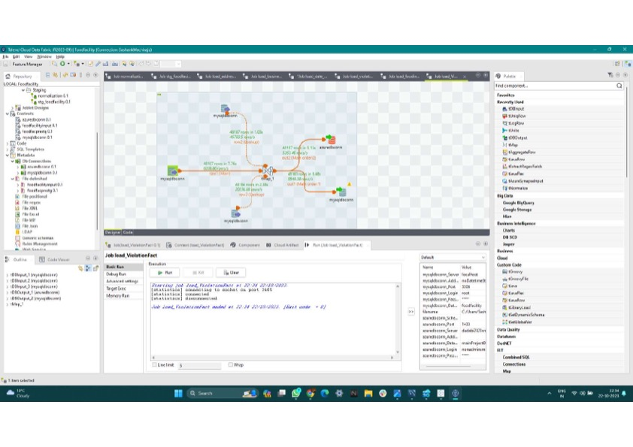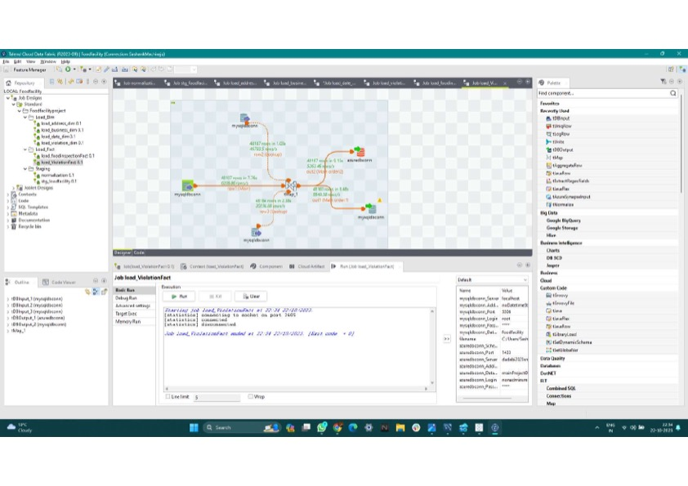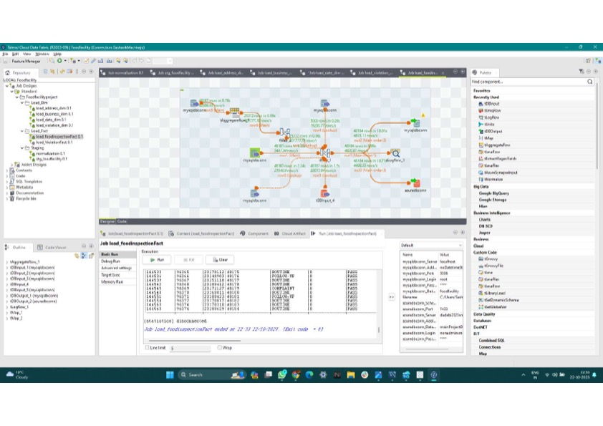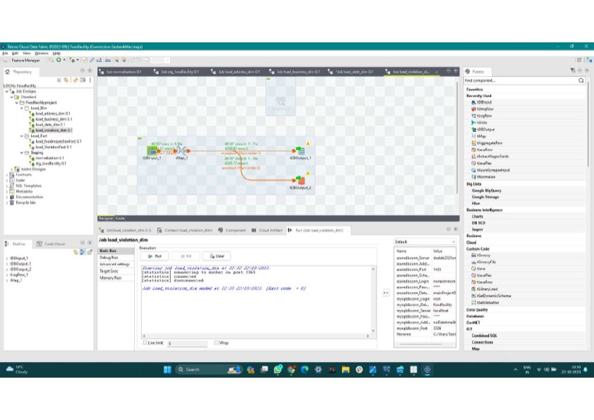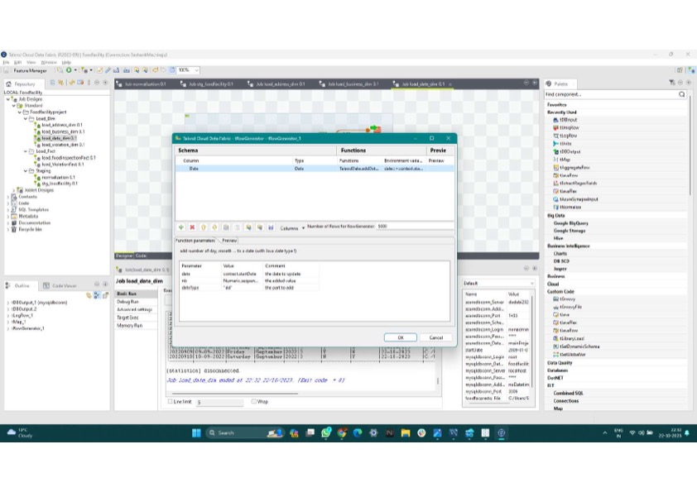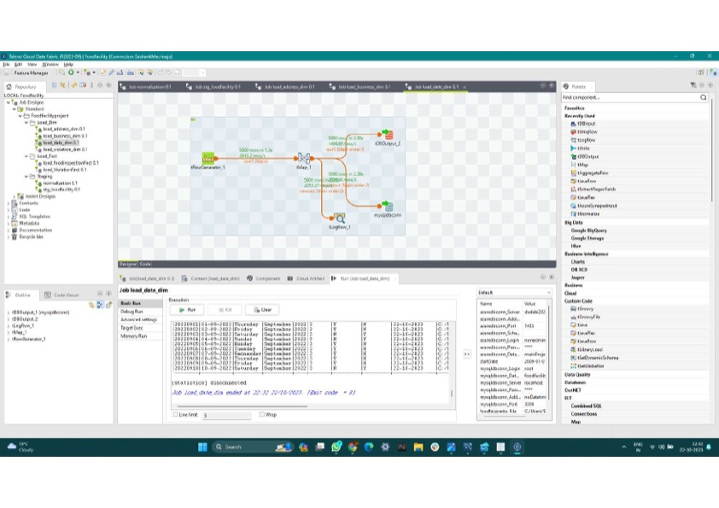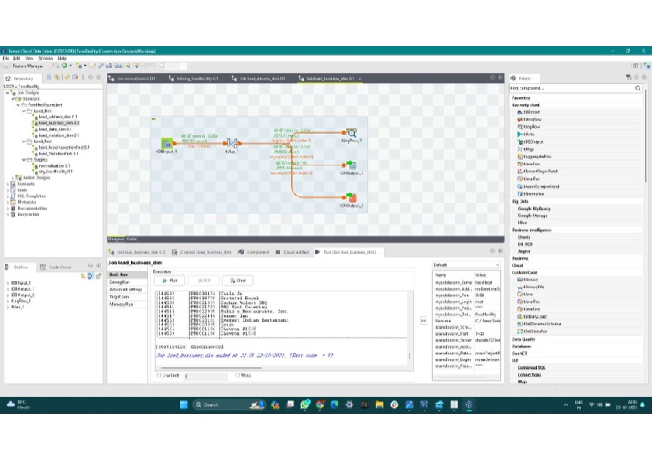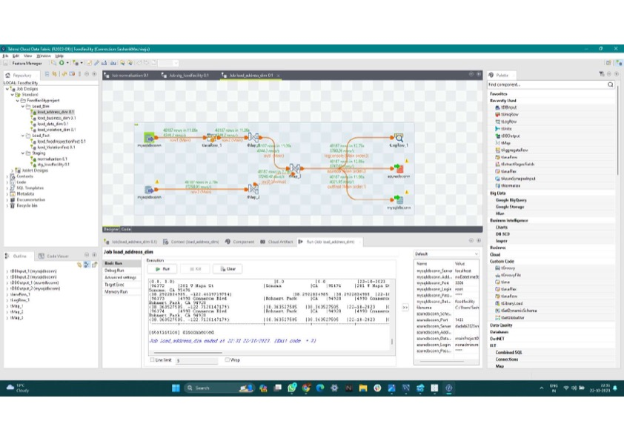

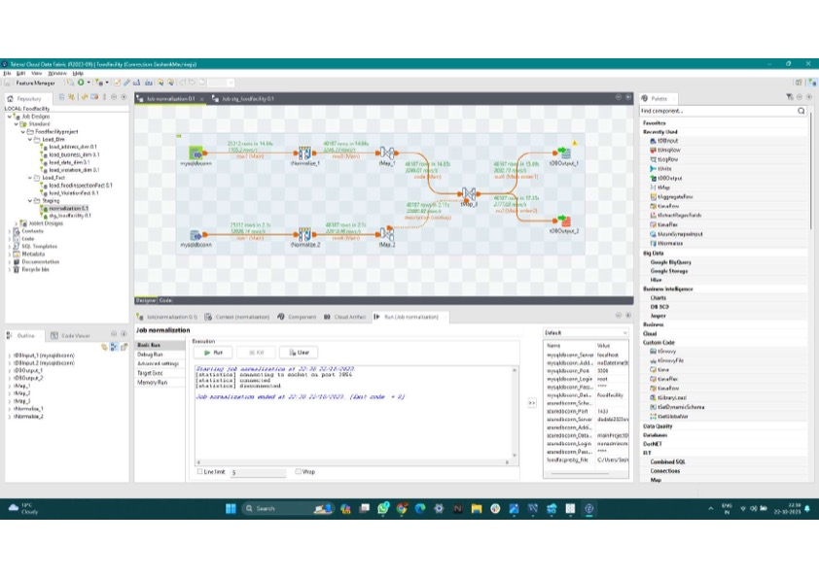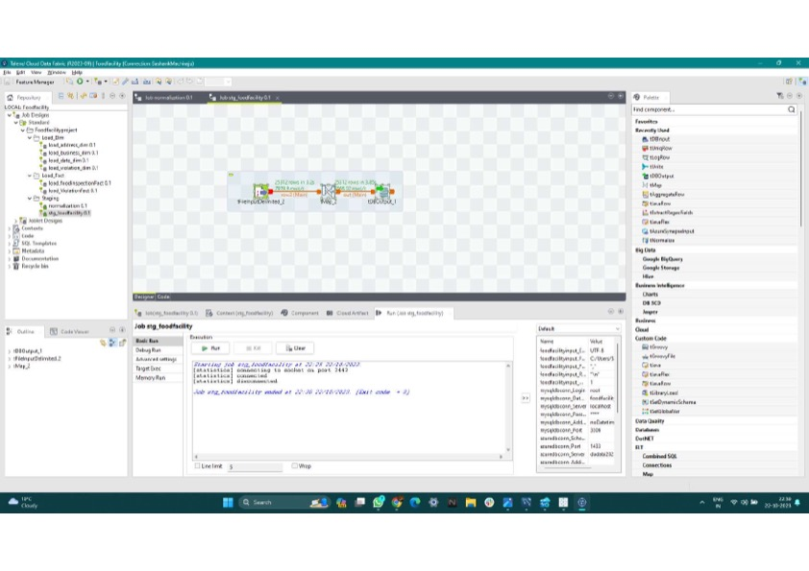

3 . Relevant DDL scripts -

DDL Azure

SET ANSI_NULLS ON

GO

SET QUOTED_IDENTIFIER ON

GO

CREATE TABLE [manyareddy].[foodfacility](

[BusinessId] [varchar](9) NULL,

[Name] [varchar](70) NULL,

[Address] [varchar](32) NULL,

[City] [varchar](17) NULL,

[State] [varchar](2) NULL,

[ZipCode] [varchar](15) NULL,

[PhoneNumber] [varchar](12) NULL,

[InspectionId] [varchar](9) NULL,

[Date] [datetime] NULL,

[InspectionType] [varchar](9) NULL,

[ViolationCodes] [varchar](4) NULL,

[ViolationDescriptions] [varchar](1000) NULL,

[Location] [varchar](100) NULL,

[DI_WorkflowFileName] [varchar](100) NULL,

[DI_CreatedDate] [datetime] NULL,

[DI_Workflow_ProcessID] [varchar](100) NULL

) ON [PRIMARY]

GO

DDL script for MySQL

'CREATE TABLE `stg_foodfacility` (

`BusinessId` varchar(9) DEFAULT NULL,

`Name` varchar(70) DEFAULT NULL,

`Address` varchar(32) DEFAULT NULL,

`City` varchar(17) DEFAULT NULL,

`State` varchar(2) DEFAULT NULL,

`ZipCode` varchar(15) DEFAULT NULL,

`PhoneNumber` varchar(12) DEFAULT NULL,

`InspectionId` varchar(9) DEFAULT NULL,

`Date` datetime DEFAULT NULL,

`InspectionType` varchar(9) DEFAULT NULL,

`ViolationCodes` varchar(4) DEFAULT NULL,

`ViolationDescriptions` varchar(1000) DEFAULT NULL,

`Location` varchar(100) DEFAULT NULL,

`DI_CreatedDate` datetime DEFAULT NULL,

`DI_Workflow_ProcessID` varchar(100) DEFAULT NULL

) ENGINE=InnoDB DEFAULT CHARSET=utf8mb4 COLLATE=utf8mb4_0900_ai_ci'

**Deliverable – 2**

**ER Diagram and Physical Model**

**Deliverable 4 –**

**Power Bi visualisations**

**Tablaeu visualisations**

